 | code of conduct | 
 | participants | attendees | wellness officers  INTRODUCTION  THIS CODE OF CONDUCT OUTLINES THE EXPECTATIONS THE COVEN AND THE FESTIVAL ORGANISERS HAVE OF ALL PARTICIPANTS,  ATTENDEES AND THE WELLNESS OFFICERS, PLUS ALL OTHER STAFF/ VOLUNTEERS AT THIS EVENT.  ALONGSIDE THE DEPLOYMENT OF WELLNESS OFFICERS, THE COVEN IS ALSO CURATING A WELLNESS AREA FOR PARTICIPANTS  TO USE. THIS IS SITUATED AMONGST A SELECTION OF THE UK’S MOST EXCITING BREWERIES HOSTED BY THE COVEN, TO SHOWCASE NOT ONLY THEIR AWESOME BEER BUT RIGHTEOUS ETHOS AND VALUES.  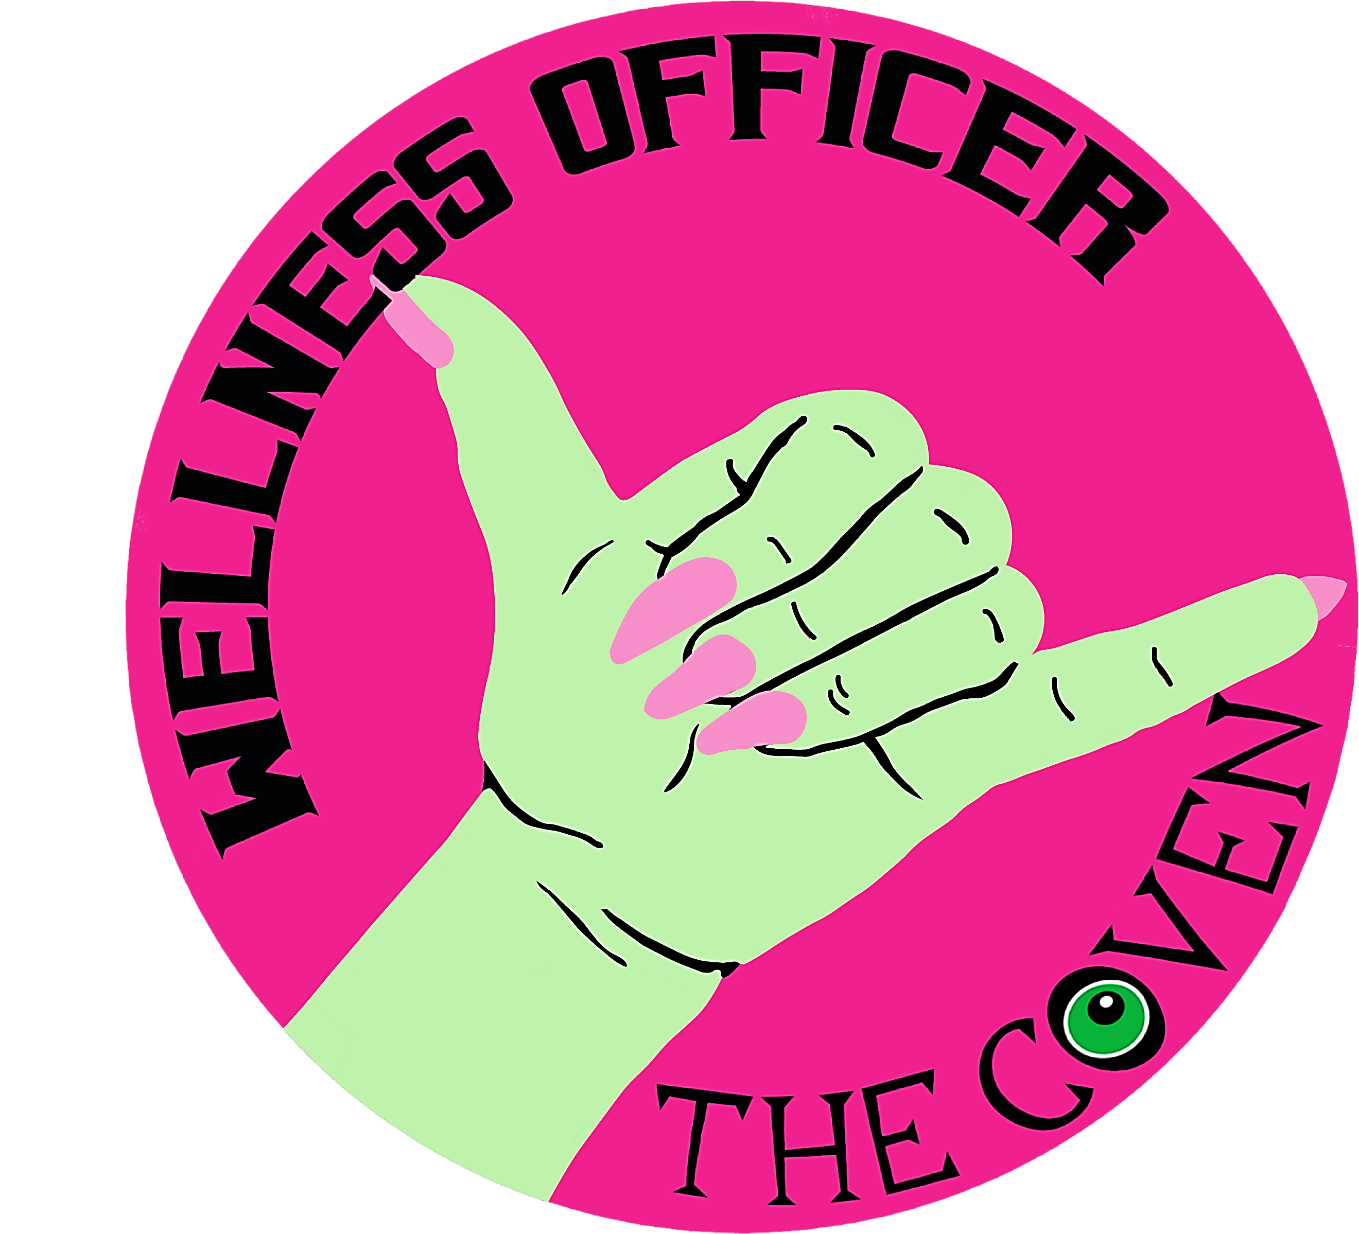  WELLNESS OFFICERS  ARE TRAINED INDIVIDUALS WHO  WILL ACT AS ACTIVE BYSTANDERS,  INCIDENT REPORTERS AND  GOODVIBE GUARDIANS FOR ALL  WHO ATTEND THIS EVENT. | THE COVEN  EXISTS TO PROMOTE,  PLATFORM AND  PARTNER WOMEN  OWNED AND  BREWED BEER.  WE RECOGNISE THAT  MAGINALISED FOLK  OF ALL TYPES FACE  PREJUDICE WITHIN  THE BEER INDUSTRY,  AND WE DO NOT  FOSTER ANY OTHER  LAYERS OF  DISCRIMINATION  BEWTEEN WOMEN  AND THEM.  WE SUPPORT AND  CHAMPION ALL  OTHERISED FOLKS  AND WITCHES WHO  CALL THE BREWING  AND BEER INDUSTRY  THEIR HOME AND  CAREER.
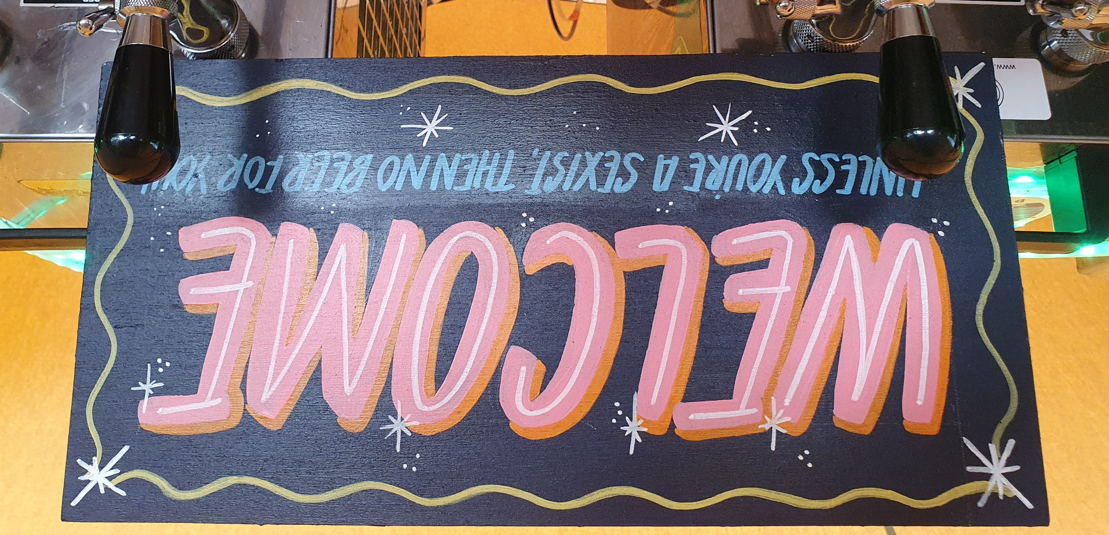

CODE OF CONDUCT
IN ORDER FOR THIS EVENT TO REMAIN ACCESSIBLE TO ALL
COVEN AND FESTIVAL ORGANISERS ASK THAT ALL IN ATTENDANCE
(ATTENDEES, PARTICIPANTS AND ORGANISERS)
ADHIRE TO THE CODE OF CONDUCT OUTLINED BELOW.
THE COVEN DEFINES INAPPROPRIATE BEHAVIOUR AS THAT WHICH UNDERMINES THE SAFETY, COMFORT OR WELLNESS OF ANY PARTICIPANT OR ATTENDEE OF THIS FESTIVAL. THIS EXTENDS TO ONLINE INTERACTIONS PRE AND POST EVENT.

- REFRAIN FROM INAPPROPRIATE AND ILLEGAL BEHAVIOUR.
- REFRAIN FROM USE OF INAPPROPRIATE LANGUAGE OR GUESTURES.
- REFRAIN FROM BIGOTED BEHAVIOUR OR LANGUAGE.
- BE AN ACTIVE BYSTANDER (WITNESS / REPORT / INTERVENE.
- HANDLE DISAGREEMENTS RESPECTFULLY.

- BE AWARE OF LANGUAGE DIVERSITY.
- SHOW RESPECT AND PATIENCE TO ALL IN ATTENDANCE.
- CONSIDER THE SAFETY OF ALL OTHER ATTENDEES AND ONESELF.
- ACCEPT GUIDANCE AND DECISIONS MADE BY ALL STAFF.


OUR PARTICIPANTS WILL BE ASKED TO
CONSIDER THE FOLLOWING ALSO:

- SHOW RESPECT AND PROFESSIONALISM TO ALL OTHER PARTICIPANTS AND WELLNESS OFFICERS.
- BE HONEST AND LAW ABIDING IN ALL DEALINGS WITH THE PUBLIC, STAFF, OTHER PARTICIPANTS AND FESTIVAL ORGANISERS.
- ADOPT THE HIGHEST POSSIBLE STANDARDS OF HYGIENE, HEALTH AND SAFETY.
- ISSUE ALL STAFF/ VOLUNTEERS WITH APPROVED FORMS OF AGREEMENTS REGARDING EXPECTATIONS, BREAK ALLOCATIONS AND REMUNERATION.
- ISSUE ALL STAFF/ VOLUNTEERS WITH APPROPRIATE TRAINING.
- ENSURE SITE, EQUIPMENT AND FACILITIES ARE SAFE AND SUITABLE FOR USE.
- ENSURE STAFF ARE ABLE TO ACCESS SAFE TRAVEL HOME ON LATE ENDING SHIFTS.

WELLNESS OFFICERS
ARE EXPECTED TO ADHERE TO THIS FINAL LAYER
OF EXPECTATIONS ASWELL:

- RESPECT PRIVACY OF PARTICIPANTS AND FESTIVAL ORGANISERS.
- RESPECT PRIVACY AND ANONYMITY REQUESTS OF ATTENDEES.
- NOT TO CONSUME ALCOHOL WHILST ON DUTY.
- RECORD ALL INCIDENTS, ACCIDENTS AND NEAR MISSES APPROPRIATELY.
- BE MINDFUL THAT PEOPLE RESPOND TO TRIGGERS DIFFERENTLY, AND SOME MAY NOT BE CLEAR OR OBVIOUS.

- GET HELP IMMEDIATELY IF FEELING UNSAFE, UNCOMFORTABLE OR OUT OF TRAINING DEPTH.
- TREAT VICTIMS WITH DIGNITY AND EMPATHY
- EXTEND GENEROUS INTERPRETATIONS OF PEOPLES’ BEHAVIOURS.
- CREATE AND MAINTAIN ATMOSPHERES OF SAFTEY, COMFORTABLENESS AND MUTUAL RESPECT.
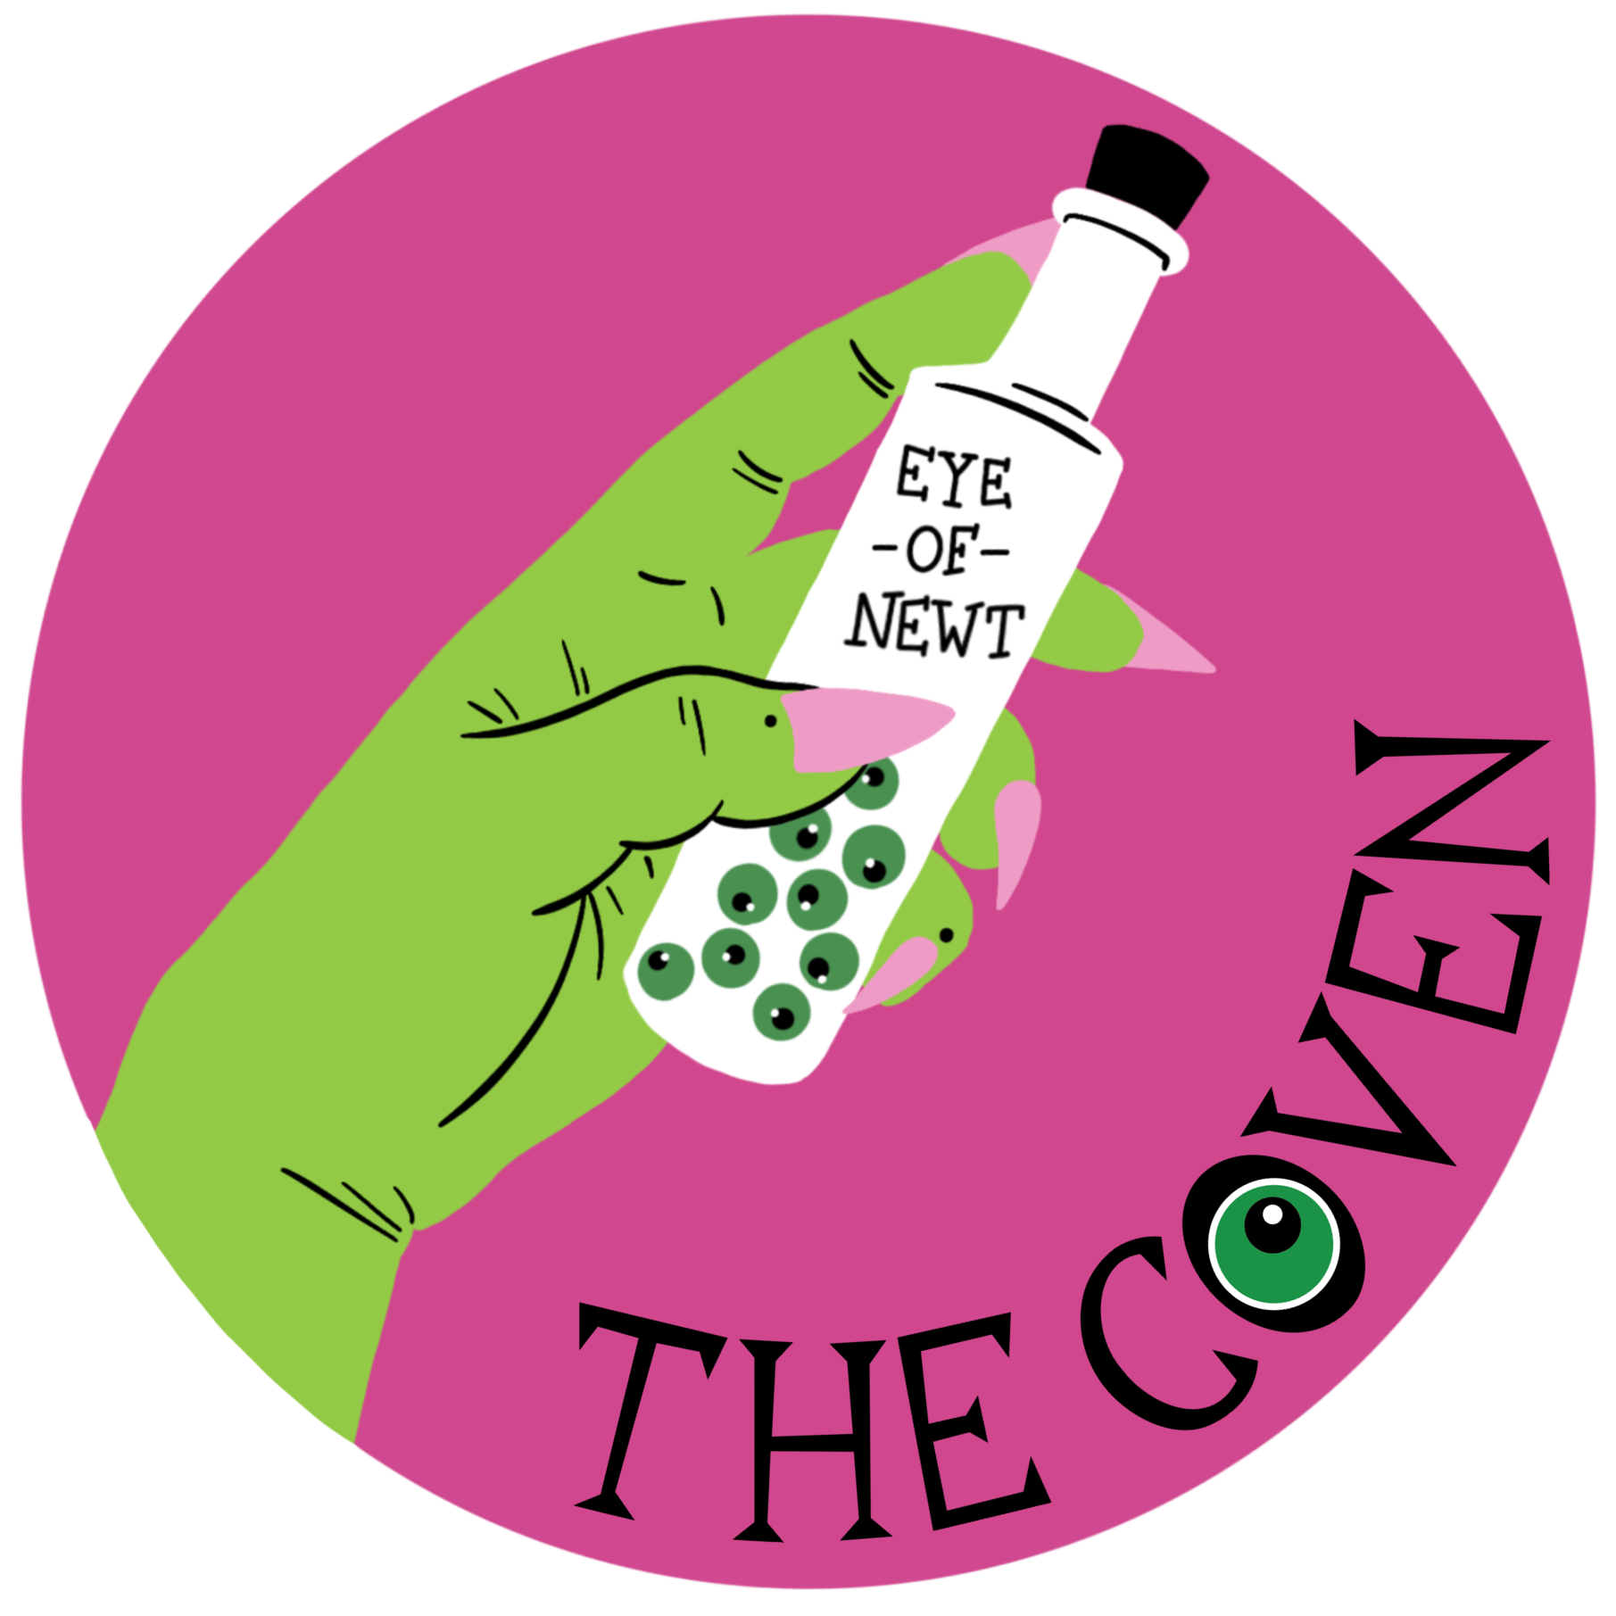
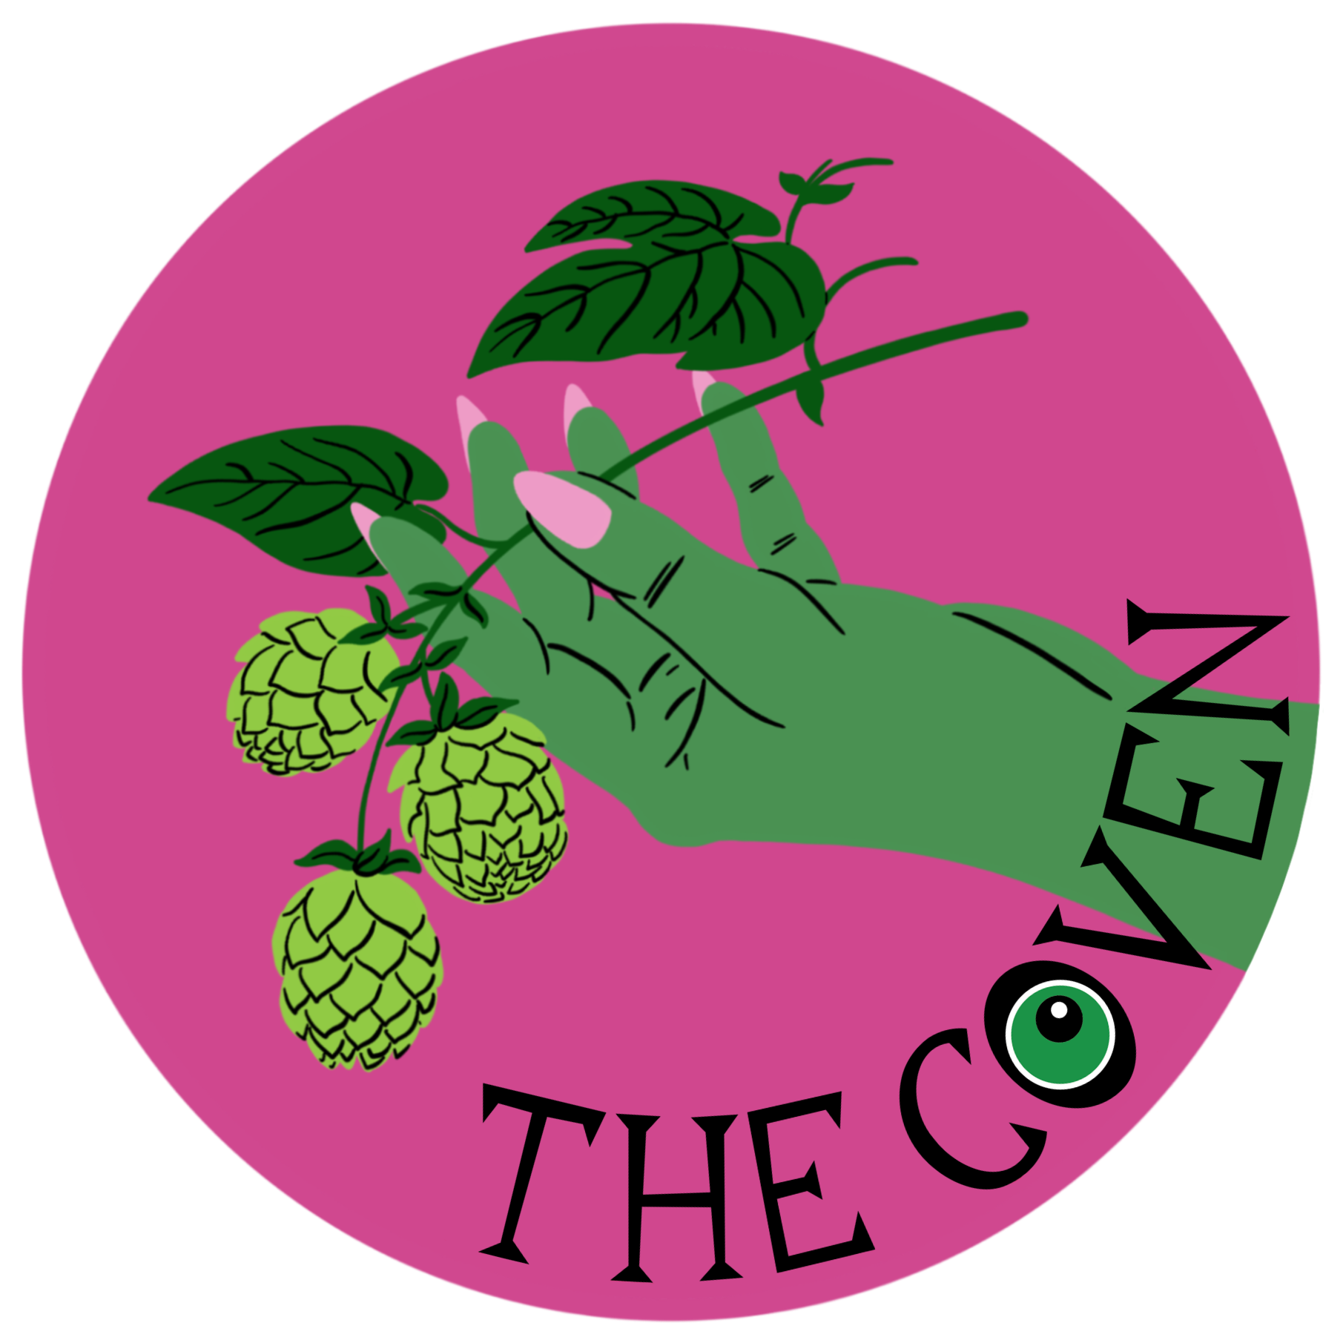


REPORTING

WE ASK ALL PARTICIPANTS AND ATTENDEES TO CONTACT A WELLNESS OFFICER OR MEMBER OF FESTIVAL STAFF ON SITE AS SOON AS POSSIBLE TO REPORT ANY SITUATION THAT MAKES THEM FEEL UNSAFE OR UNCOMFORTABLE.
NOTIFYING THE COVEN OR FESTIVAL ORGANISERS IS NOT A REPLACEMENT FOR CONTACTING THE POLICE OR EMERGENCY SERVICES.

THE COVEN AND FESTIVAL ORGANISERS WILL UTILISE THEIR DISCRETION WHEN ADDRESSING ANY INDIVIDUAL(S) OR GROUP(S) THAT THEY FEEL HAVE VIOLATED OR FAILED TO ENACT ANY OF THE EXPECTATIONS OUTLINED IN THE CODE OF CONDUCT. INCLUDING, BUT NOT LIMITED TO, REVOKING VIOLATING PARTIES ACCESS WITHOUT REFUND OR RECOMPENSE. DECISIONS WILL BE MADE ON A CASE BY CASE BASIS.
THE COVEN WILL PRIORITISE THE NEEDS OF MAGINALISED AND VULNERABLE PEOPLE’S SAFETY, AND RESERVES THE RIGHT TO NOT ACT UPON COMPLAINTS REGARDING ‘ REVERSE-ISMS’ AND REASONABLE COMMUNICATION OF BOUNDARIES OR COMMUNICATION STYLES / TONE DEEMED UNDESIRABLE TO THE COMPLAINTANT.

PLEASE EMAIL WOP@30SIXCO.COM IF YOU BELIEVE YOU HAVE EXPERIENCED OR WITNESSED A VIOLATION, INCLUDING ONLINE OR WITHIN ANY SOCIAL MEDIA ASSOCIATED WITH THIS EVENT.
PRIVACY WILL BE RESPECTED AND REQUESTS FOR ANONYMITY WILL BE HONOURED

